**July 2025**

**Parents newsletter intro**

**E-scooters and e-bikes**

Does your child ride an e-scooter or e-bike? Did you know that **only** children 16 and over are allowed to ride e-scooters unsupervised? Is their e-bike legal? If your child’s device has any of the features below, it is illegal to ride in public, and they (or you) may be subject to significant penalties.

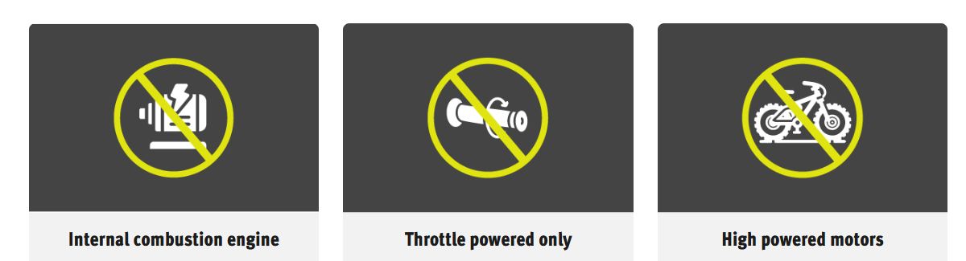

Click this link to get information on e-bikes and e-scooters

[https://streetsmarts.initiatives.qld.gov.au/e-bikes-e-scooters/](https://urldefense.com/v3/__https:/streetsmarts.initiatives.qld.gov.au/e-bikes-e-scooters/__;!!O42koZAH9g!bCLAc_mdruXFPOOKivel2iNw5_8HpttIsZFKWTfvo2RWr0pHDEB1bKfu89PZE9YHab3KFG6hS3Ao_1vQsbZb8vqeJak6oN7ciu9u$)

**DRAFT ARTICLE FOR NEWSLETTER**

**E-scooter and E-bike rules**

E-scooters, e-skateboards, and solo wheels have a separate set of rules to e-bikes. Here in Queensland, riders of legal e-bikes must follow the same rules as standard bicycles.

E-scooters rules

To ensure you and your child know the rules to stay as safe as possible when using e-scooters or e-skateboards, visit [StreetSmarts Qld](https://streetsmarts.initiatives.qld.gov.au/pmd/get-the-facts/) for a quick and easy to understand listing of the rules and fines. Most importantly, remember:

* Only those **aged 16+** can ride e-scooters and e-skateboards **unsupervised**.
* **Helmets must be worn** with the straps properly fastened (bicycle or motorcycle helmets) and bells fitted for devices with handlebars.
* **No passengers**/doubling – only one person riding an e-scooter.
* **Speed limit of 12km/h** on footpaths and shared paths.
* Serious fines may apply to riders, and parents, if caught breaking the rules.

[StreetSmartsQld](https://streetsmarts.initiatives.qld.gov.au/pmd/get-the-facts/) also features educational videos and other helpful safety tips for riding e-scooters and e-skateboards.

E-bike rules

Beware that some e-bikes are illegal. In order to legally ride an e-bike on public roads and footpaths, it must comply with the following:

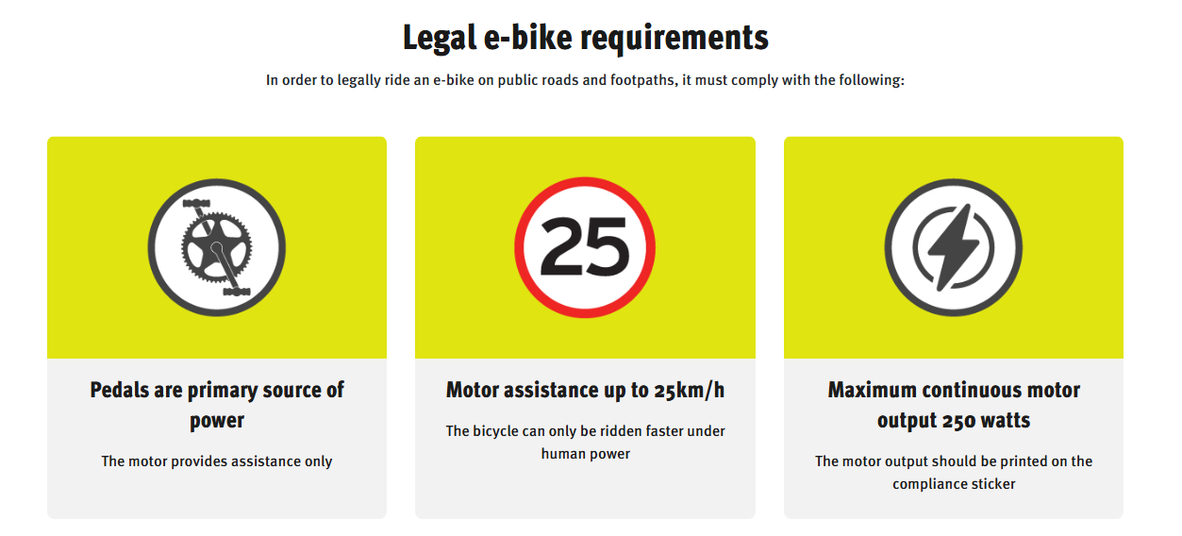

There has been a huge increase in devices that are thought to be e-bikes but are in fact illegal motorbikes. They are banned from use and riders (or parents) can face significant penalties totalling more than $1,640.

You can’t ride your device on a path or road if it has any of these:

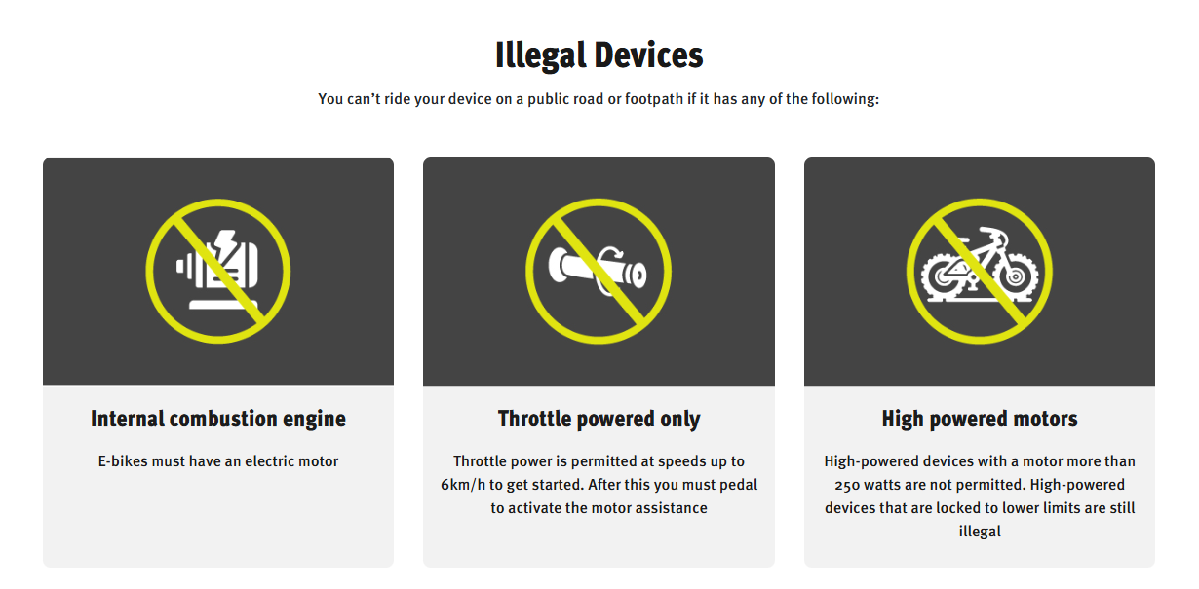

Already have one of these devices in your home, or considering buying one? Visit [Electric Bikes | StreetSmarts - Queensland Government](https://streetsmarts.initiatives.qld.gov.au/electric-bikes/) to find out more about the rules for legal devices as well as the rules for riding.